**VEHICLE MANAGEMENT SYSTEM USING SALESFORCE**

Vehiclemanagementisanapplicationwhere a customer details are stored in order to choose cars, bikes and commercial vehicles for travel within the city. The data which is stored here, further used to remind them if any offers are provided during the seasons and any updates regarding vehicles are sent to them in the form of messages and mails.

* **Creating developer account**

Below are the steps to create developer org.

* Go to developer.salesforce.com/signup.
* On the sign up form enter all the required details click first name, last name, email, role etc.
* Click on sign me up.

Created a new developer org in salesforce and connected this org to the main account.

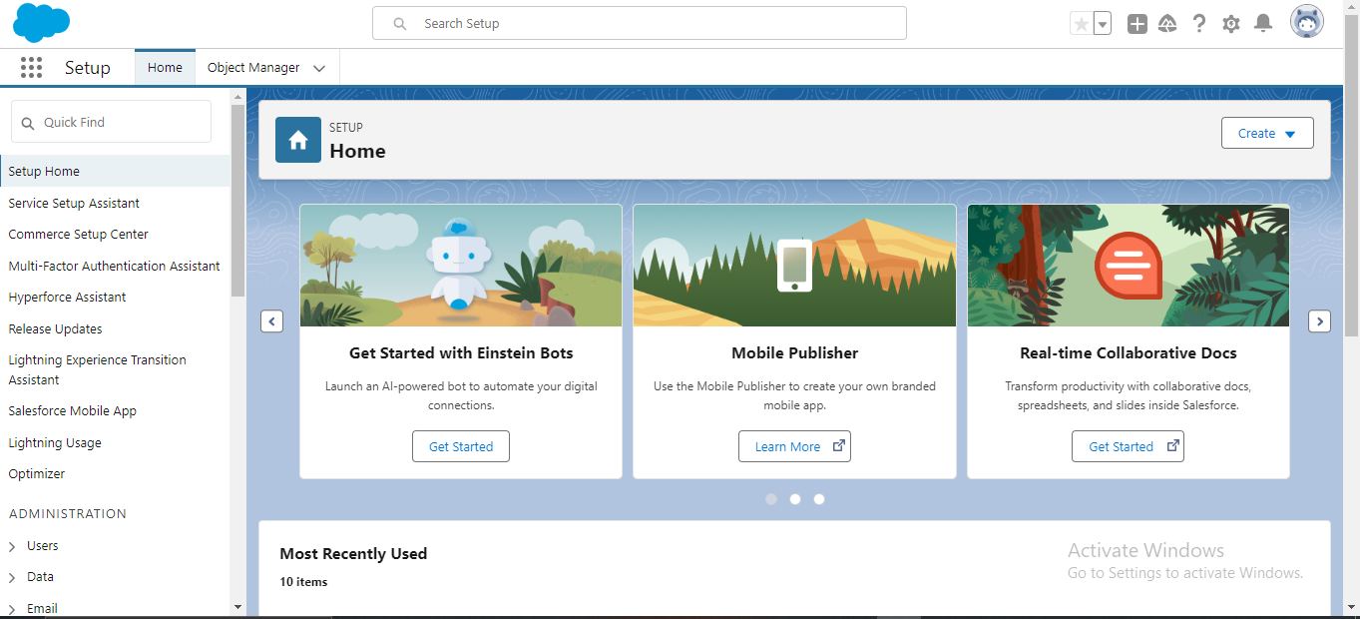

* **Objects**

Objects are tables in the salesforce database that store a particular kind of information. There are two types of objects they are standard objects and custom objects.

* **Standard object :** standard objects are the objects that are provided by the salesforce.com like account, opportunity etc.
* **Custom object :** custom objects are the objects that are created by us.

In vehicle management system we will be using standard and custom objects.

Standard objects are account, contact, opportunity.

Custom objects are vehicle, driver, traveler.

* **Create a vehicle object**

The below steps are to create the custom objects i.e. vehicle object, driver object, traveler object.

* Click on the object manager tab which is beside the home tab.
* On the extreme right click on the create dropdown box and then select custom object.
* On the custom object page, create the object by filling all the details like label, plural label, record name etc.
* Click on save.
* Select the tab style and click next, next, save.

Follow the above same steps to create driver object and traveler object.

* **Vehicle object**

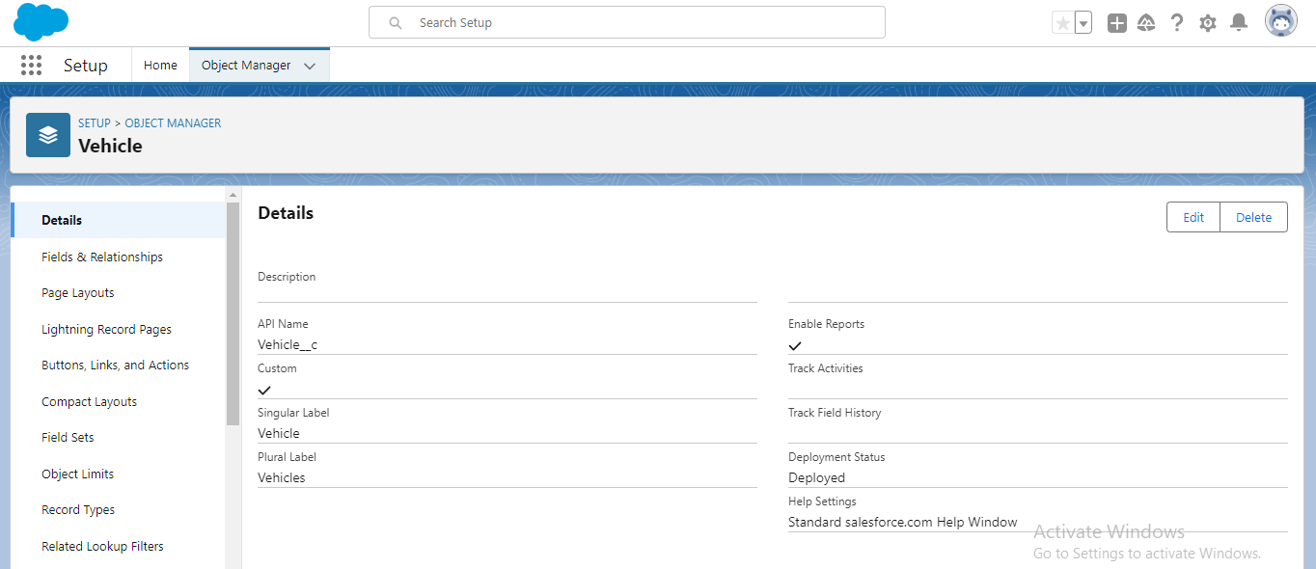

* **Driver object**

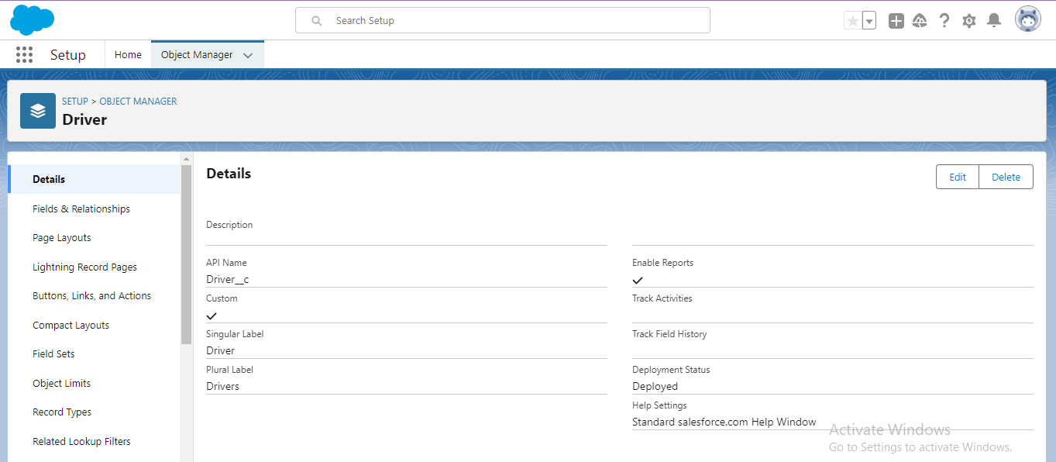

* **Traveler object**

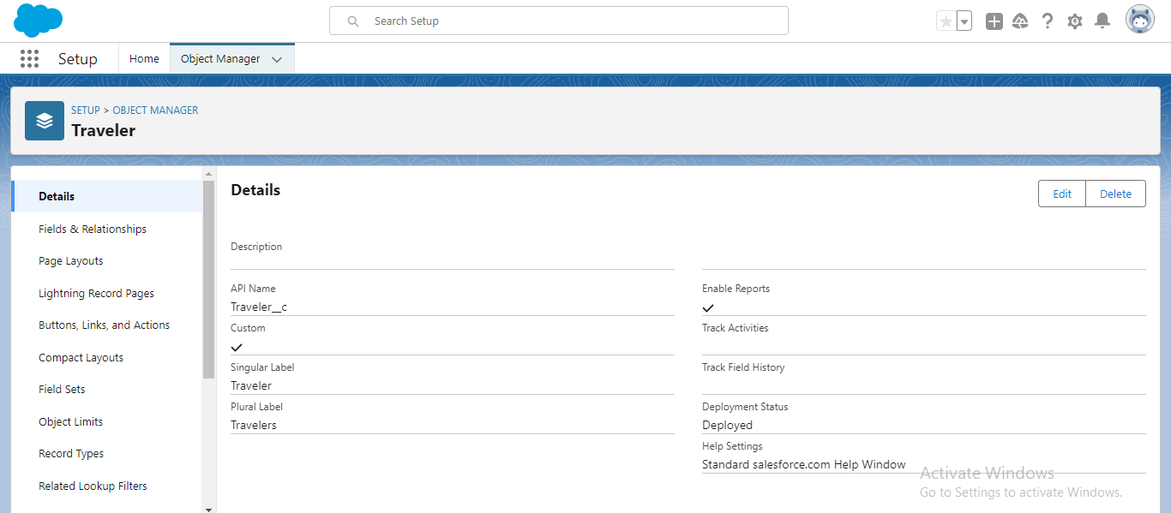

* **Fields and relationship**

An object relationship in salesforce is a two way association between two objects. Relationships are created by creating custom relationship fields on an object. This is done so that when users view records they can also see and access related data.

* Go to fields and relationships of required object like vehicle object and click on new.
* Select the data type and click next.
* Enter details and click next, next , save.
* **Fields of Vehicle object**

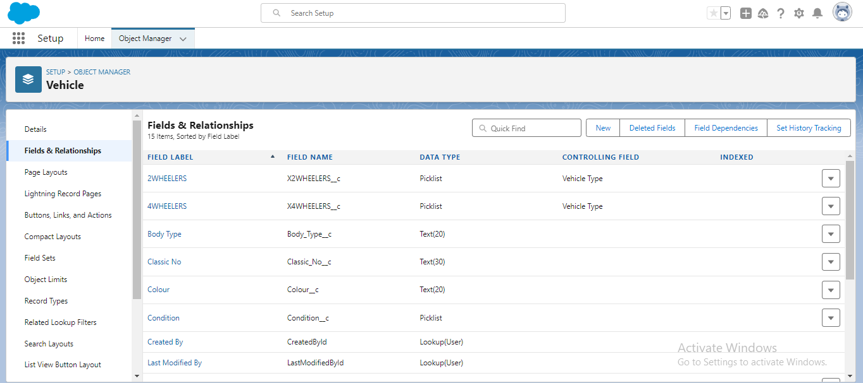

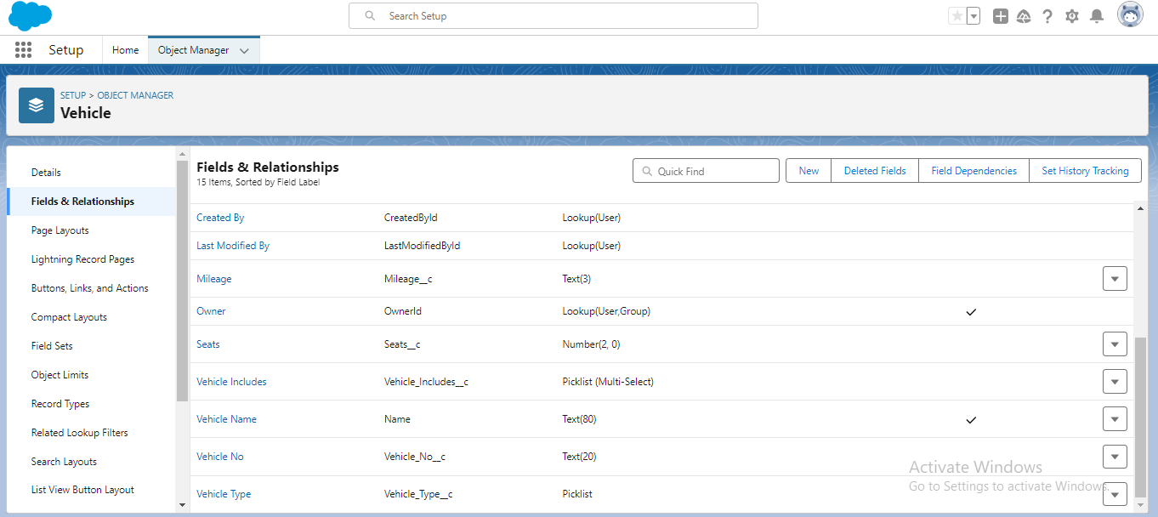

* **Fields in Driver object**

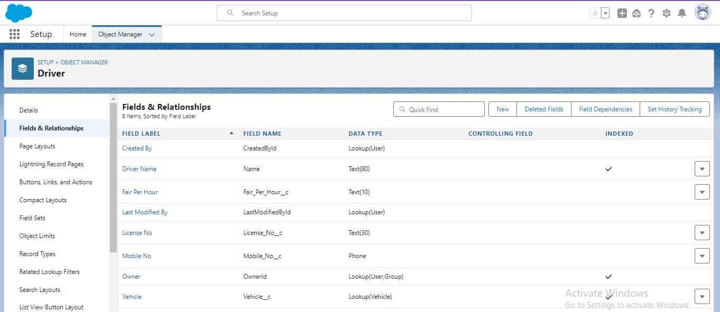

* **Fields in Traveler object**

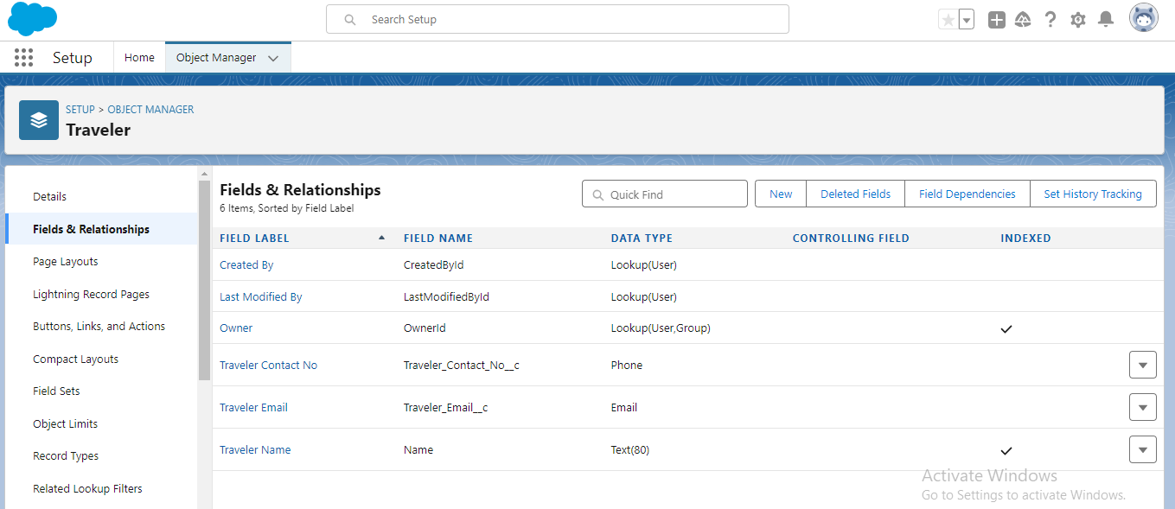

* **Fields in opportunity object (standard object)**

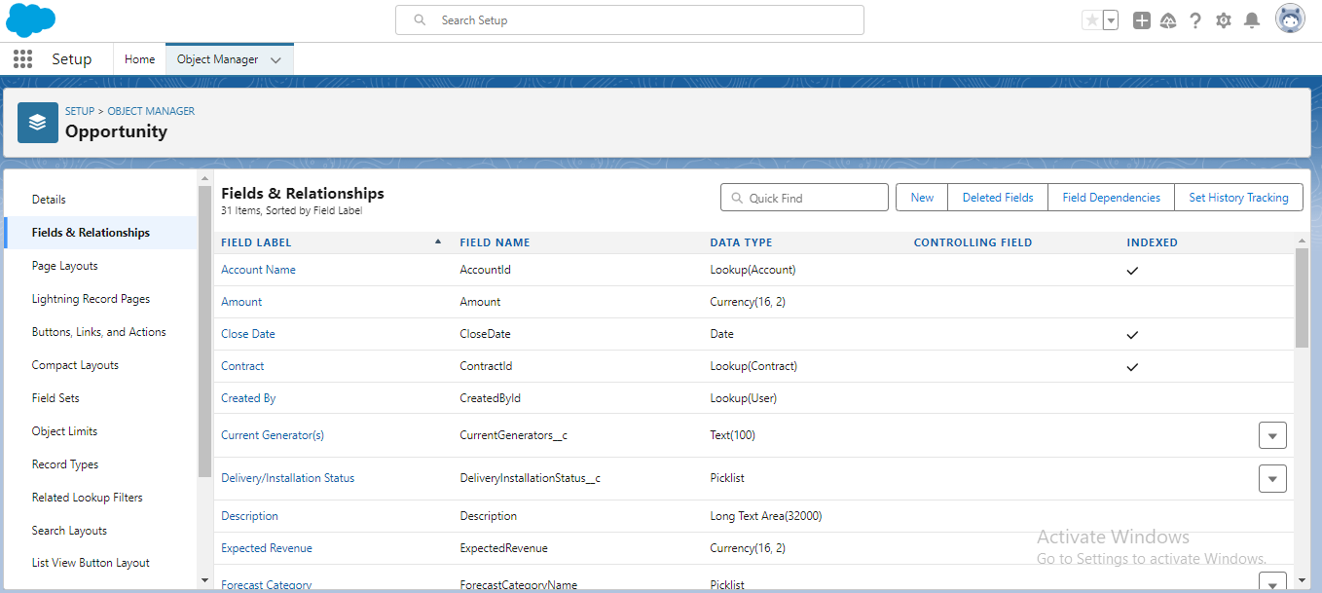

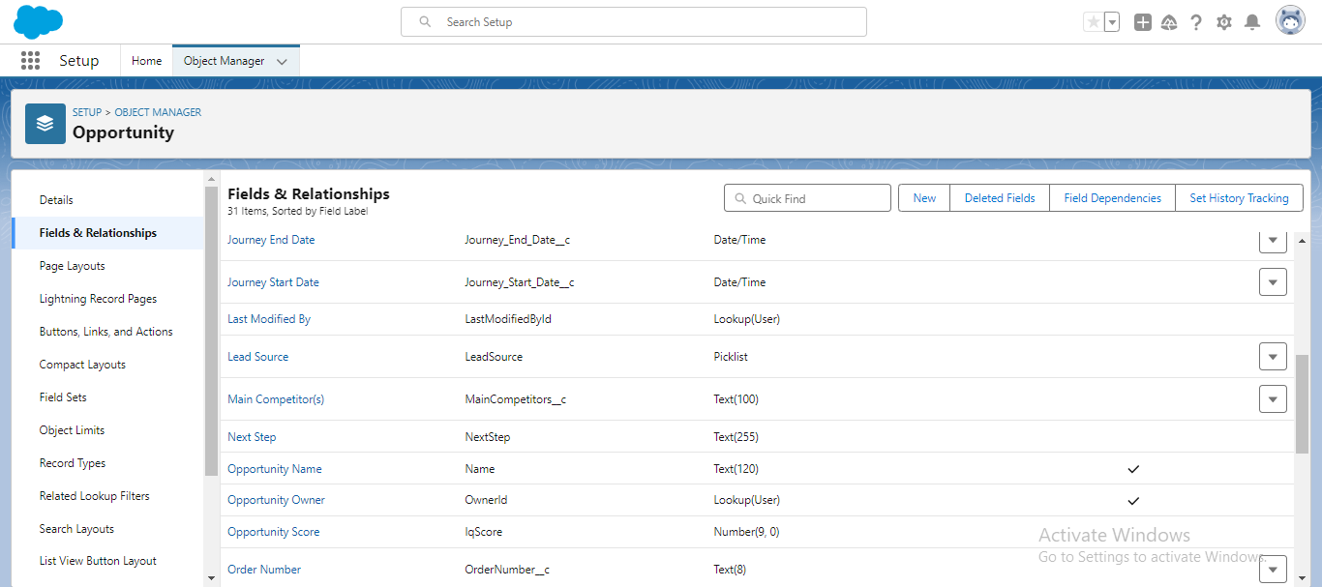

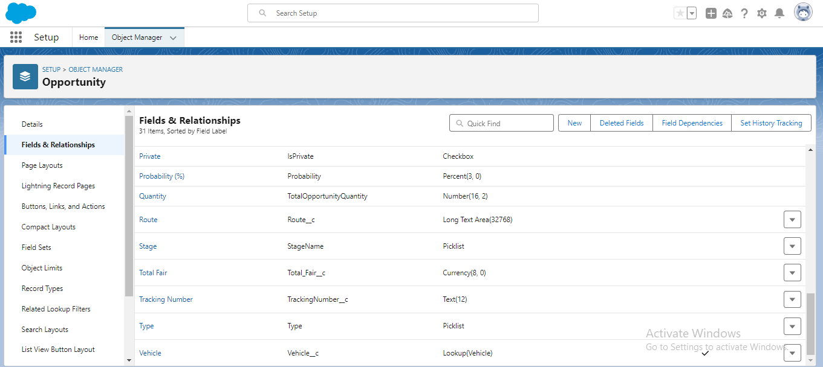

* **Lightening app**

**Create the vehicle management app**

The below steps are to create the vehicle management app

* From setup, enter app manger in the quick find and click on app manager.
* Click on new lightening app, enter Vehicle Management as the app name and then click next.
* Under app options, leave the default and click next.
* In utility items without making any changes click on next.
* In the available items select Accounts, Contacts, Opportunities, Vehicle, Driver, Traveler, Reports and Dashboards and move them to selected items and click next.
* From available profiles select System Administrator and move it to selected profiles. Click save and finish.

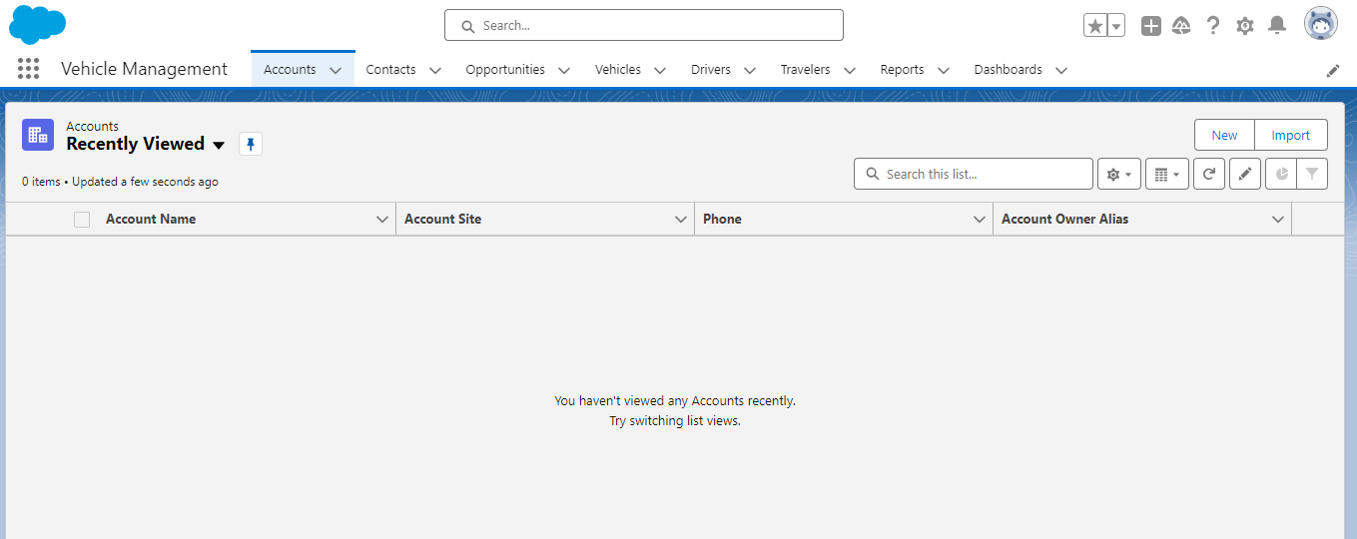

* **Profiles**

A profile is a group/collection of settings and permissions that define what a user can do in salesforce.

* **Create a profile**

The below steps are to create a vehicle manager profile and set its object permissions.

* Enter profiles in the quick find box and select profiles.
* Click on the clone of the standard user.
* Give Vehicle Manager as profile name and click save.
* In the vehicle manager profile click on edit and scroll down to custom object permissions and give all access i.e. create, read, edit, delete, view all and modify all for vehicle object, driver object and traveller object.

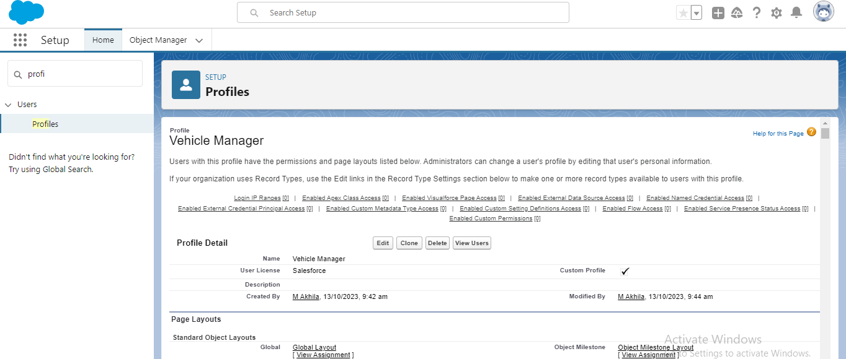

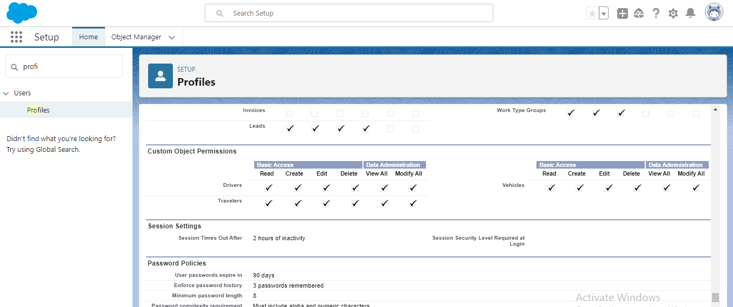

* **Setup roles**
* Enter roles in the quick find box and select Roles.
* Click on Set up Roles then click on Expand all.
* Under the CEO click on Add Role.
* Fill all the details and click on save.
* Under vehicle manager create 2 new roles.

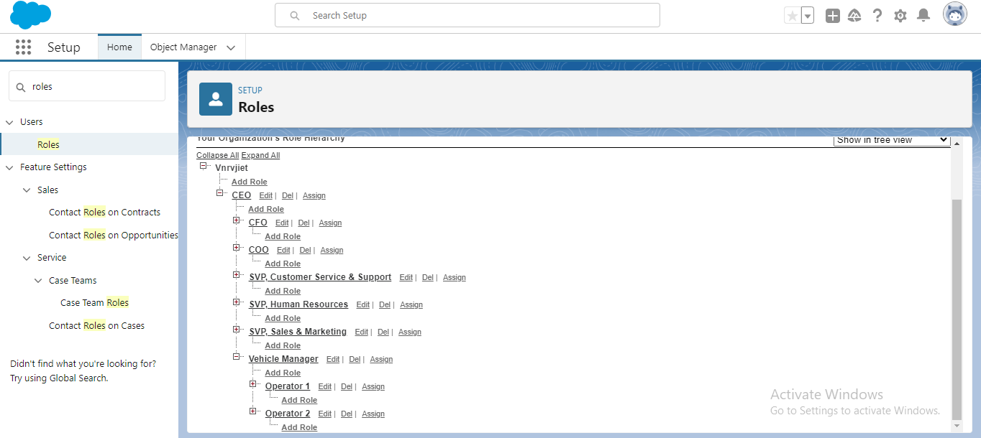

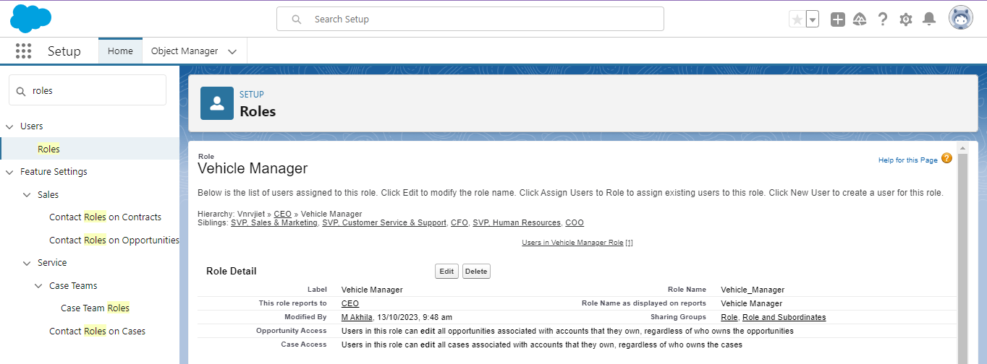

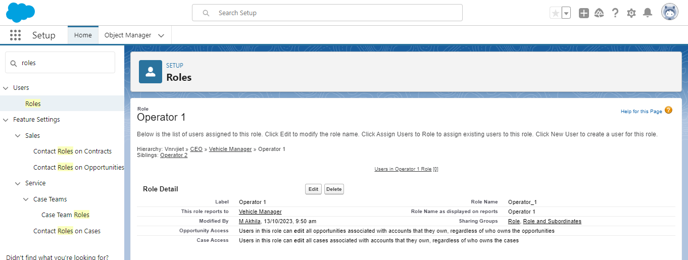

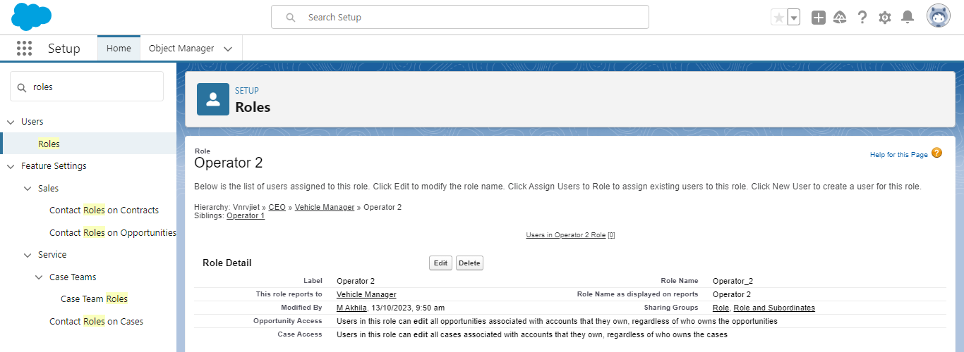

* **Users**

A user is anyone who logs in to salesforce. Users are employees at your company such as sales reps, managers, IT specialists who needs access to the company’s records. Every user in salesforce has a user account.

**Create a user**

The below steps are to create a user.

* Enter users in the quick find box and select users.
* Click on new user and enter all the details.

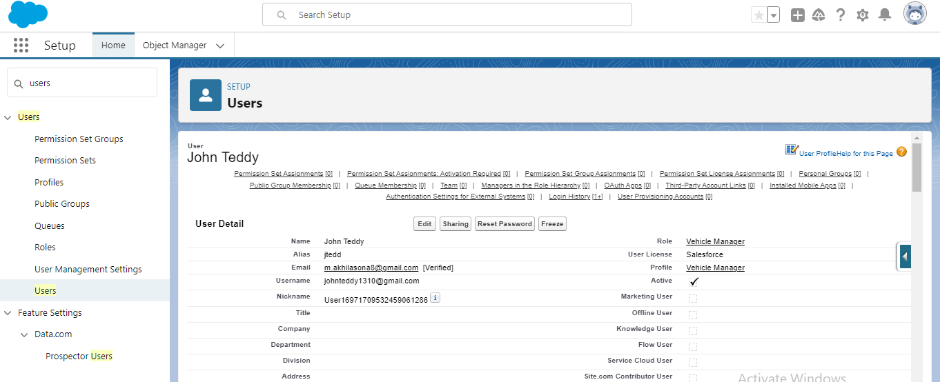

* **User adoption**
* **Create a vehicle record**

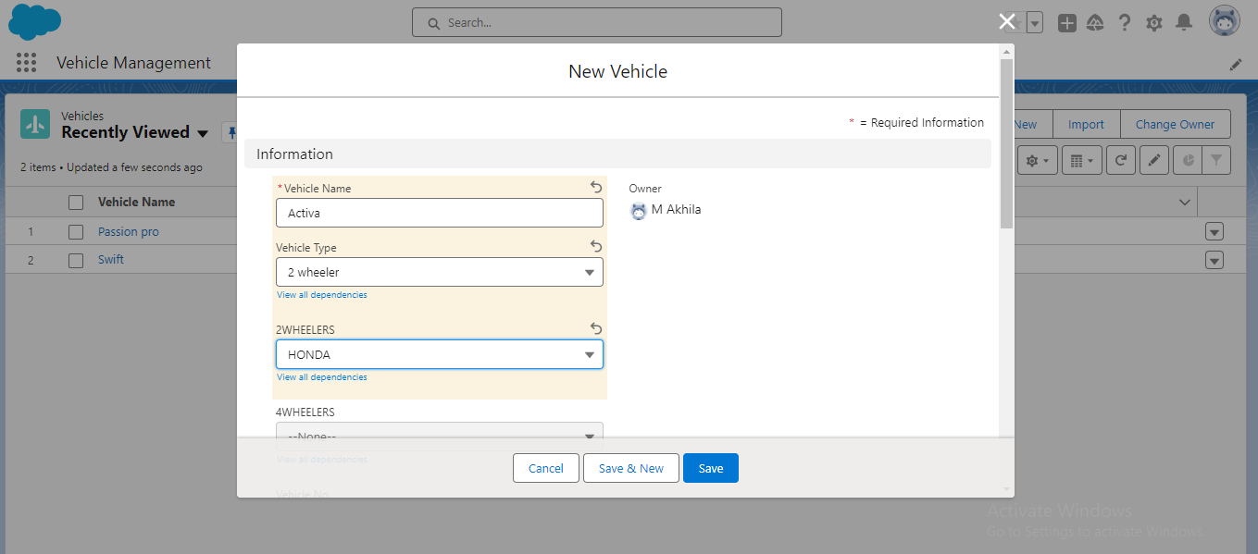

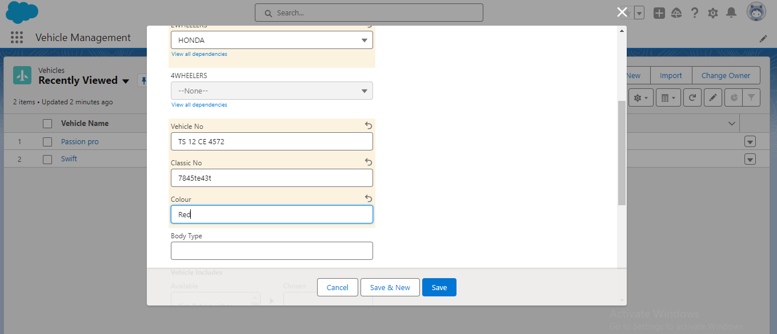

* **View the record**

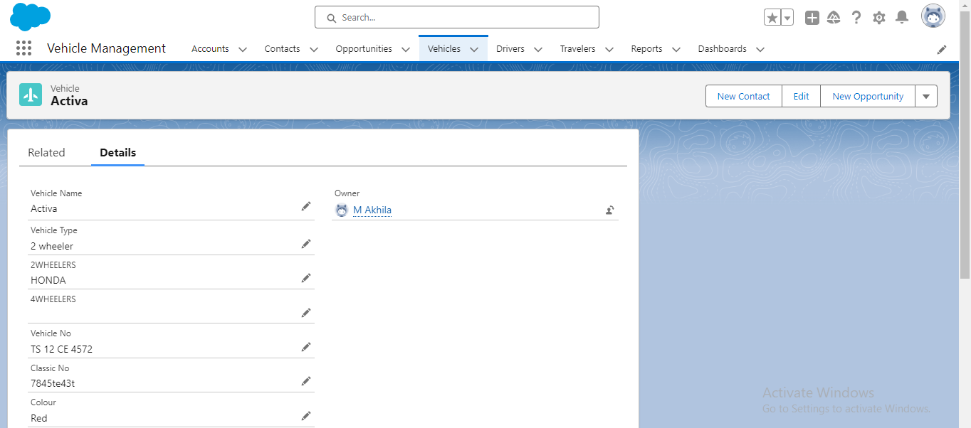

* **Reports**

Below are the steps to create report

* Go to reports and click new report.
* Select vehicles and click on start report.
* Add filters and required columns.
* Click save.

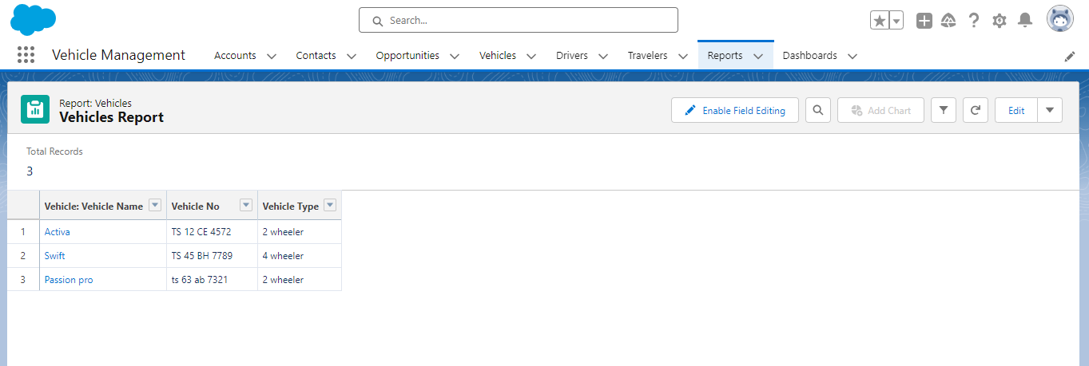

* **Dashboards**

Below are the steps to create dashboard

* Click on the dashboard tab and click new dashboard.
* Name the dashboard Vehicles dashboard and click create.
* Click on +component and select the vehicles Report and click select.
* Click save and done.

